[Ravi Patel] Instructor: Dr. Hindo

[CPSC 230]

Chapter 7 part 2 - lab assignment

(15 points)

Due date: End of this class

Note: Submit your assignment in the inbox (chapter 7 assignment-part 2).

Write your code and output for each program.

**Initialize 3*3 array and write the following functions:**

**double sum_column (a, column_no) // return the sum of a column**

**void sum_row (a, array_sum_row ) // sum rows and save in**

**// array_sum_row**

**double determinant (a) // return the determinant of array a**

**where the determinant of 3*3 matrix is calculated as :**

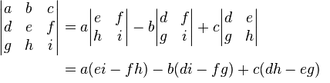

**And the determinant of 2*2 matrix is calculated as:**

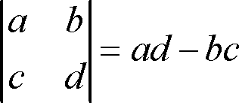

//CPSC 230 RAVI PATEL ASSIGNMENT 7 PART 2

#include <iostream>

using namespace std;

int a[3][3],i,j;

int determinant=0;

void calc_determinant(); // return the determinant of array a

void input();

void display();

int main() {

input();

display();

calc_determinant();

}

void input(){

cout<<("Enter the 9 elements of matrix: ");

for(i=0;i<3;i++)

for(j=0;j<3;j++)

cin>>a[i][j];

}

void display(){

cout<<"\n"<<("The matrix is: ")<<"\n";

for(i=0;i<3;i++){

for(j=0;j<3;j++){

cout<<(a[i][j])<<"\t";

}

cout<<endl;

}

}

void calc_determinant(){

for(i=0;i<3;i++)

determinant = determinant + (a[0][i] * (a[1][ (i+1) % 3 ] * a[2][ (i+2) %3 ] - a[1][(i+2)%3] * a[2][ (i+1) % 3] ) );

cout<<"\n"<<"Determinant of the matrix is: "<<determinant;

}

**SAMPLE OUTPUT:**

**Enter the 9 elements of matrix: 393 381 384 12 49 3 0 1 9 12**

**The matrix is:**

**393 381 384**

**12 49 3**

**0 1 9**

**Determinant of the matrix is: 135594**